Enemy Placement System Scripts :  
EnemyPlacement, CreateRoom, SpawnArea

These three scripts make up the Enemy Placement System.

Enemy Placement Script:

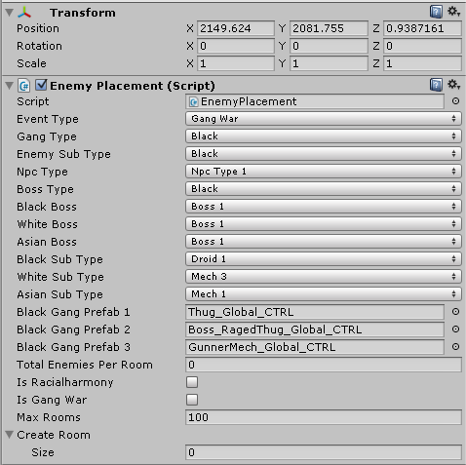

The EnemyPlacement script is attached to an empty gameobject in the level. This is the main script and it has a variety of options(some of them are just placeholders for now, currently only the black thug is functioning).

The next is the CreateRoom script:

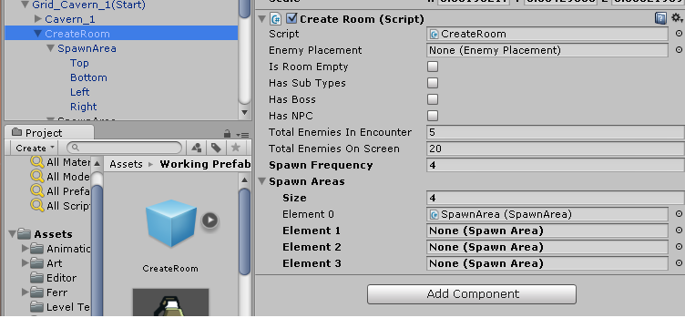

This script effectively creates the room based on the parameters passed from the EnemyPlacement script. It's fairly simple, and there is a public method called SpawnSequence() that can be called from an event(like defeating all the enemies in a wave), to spawn the next batch until the room requirements are met.

The third script is the SpawnArea script:

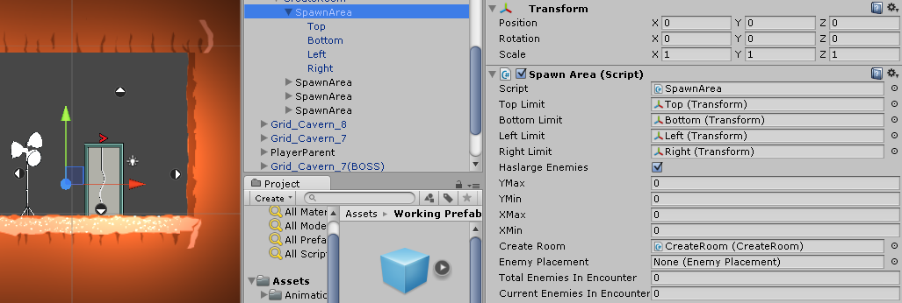

There are 4 spawn areas in a default room. This can be easily adjusted. As you can see above there are 4 arrows. Up,down,left, right. These are the bounds of the random spawn for that area. Keep in mind if you want the enemy to spawn on the floor (if you want the enemy to come out of a door, etc.)the top bound should be near the bottom bound like so:

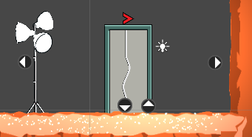

This will give the effect like the enemy just walked out the door.